User Management

# Field Requirements

1. Name: The name of the user.
   1. Required field.
   2. Max length is 255 characters.
2. Email: The users email address.
   1. Required field.
   2. This will be their username.
   3. Max Length is 255 characters.
3. Password: The password the user will use to authenticate their identity.
   1. Required for user creation. Not available when editing a user.
   2. Minimum Length is 6 characters.
4. Password Confirmation
   1. Required for user creation. Not available when editing a user.
   2. Must match first password entered.
5. Administrator Checkbox
   1. Allows user access to the Admin menu.
   2. Allows user to edit invoices that they did not create.
   3. Not required.

# Adding a User

## Step By Step Directions

1. Click the Admin dropdown and choose Manage Users

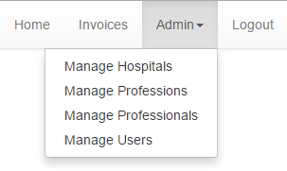

1. Click the 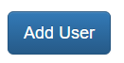button.
2. Enter the information for the fields.
   1. Required Fields
      1. Name
      2. Email
      3. Password
      4. Password Confirmation
   2. Optional Fields
      1. Administrator Checkbox
3. Click Create User

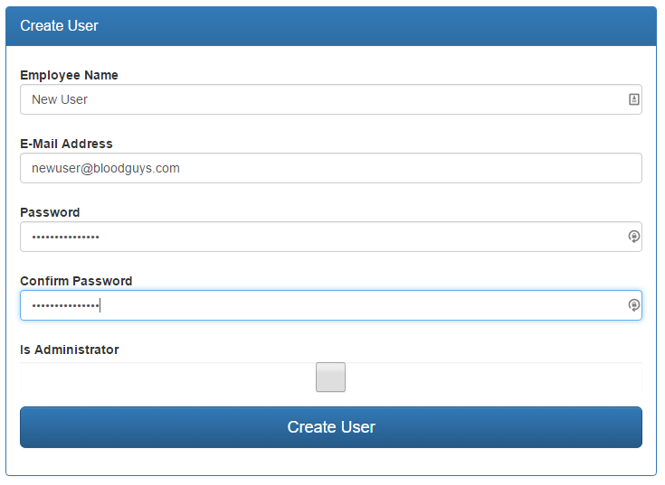

1. If successful you will see a green success message. If there was an error you will see a red error message.

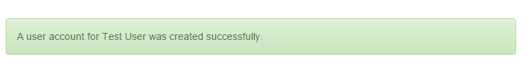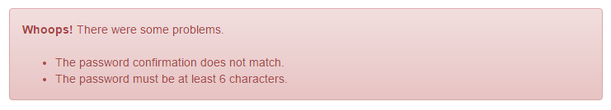

# Editing a User

## Step By Step Directions

1. Click the Admin dropdown and choose Manage Users



1. Click the Edit button.
2. Modify the information as needed.
   1. Required Fields
      1. Name
      2. Email
   2. Optional Fields
      1. Administrator Checkbox
3. Click Update User

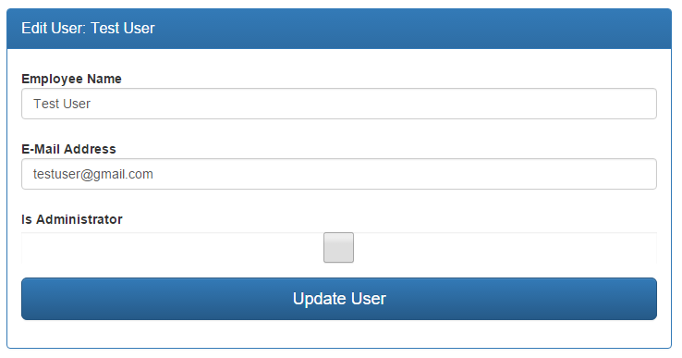

1. If successful you will see a green success message. If there was an error you will see a red error message.



